Some problems and facts about linguistic useful for natural language processing

Morphology and Morphosyntax

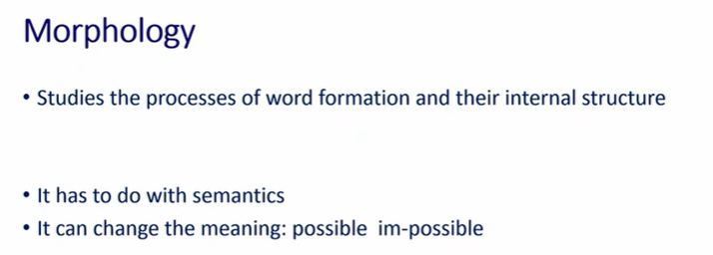

Morphology: studies the process of word formation and their internal structure of the words

has to do with semantic, some meaning that you obtain through morphological processes can have semantic impact.

possible ⟹ add im you get impossible (negative)
there is a difference in meaning, this difference come from the morphine im

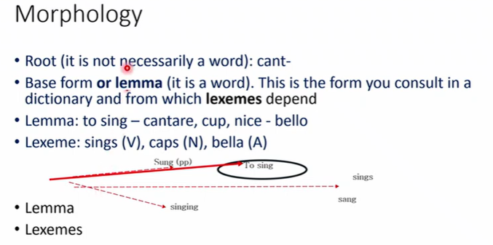

root: not necessary a word (cantare has root cant-)
in english the root is generally a word, in italian is usually not a word
base form or lemma: is a word, is what you look in the dictionary

from the base form you derive the lexeme: different words obtained by the modification of the lemma

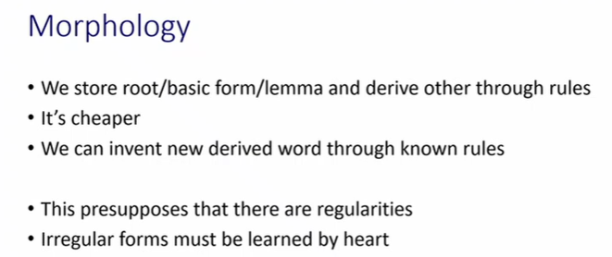

we memorized lemma and we derive by rules the lexemes
we store lemmas and we derive the others words, cheap proceduers

you can not derive irregular verbs, have to be learned by hard

there are regularities

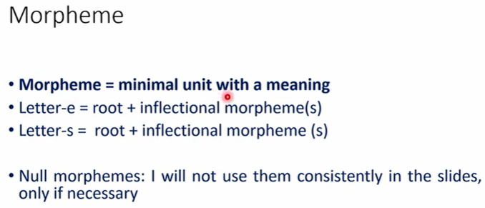
morpheme: minimal unit with a meaning

letter-e = root-inflectional morpheme(s)

when the letter in english in the singular there is no morphones, it is assumed that there is a null morpheme. Useful for natural language processing, otherwise if it is just a word you don’t know how to use it

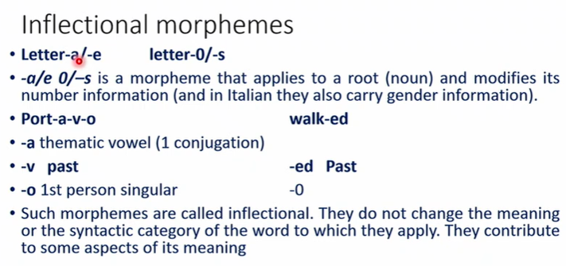

in italian you have root and 2 morphones one for singular and one for plural
the morhpones -a -e encode the quantity and the gender
letter-a/-e

the corresponding in english is letter-0/-s

--8

port-a-v-o (verb) correspond to walk-ed
italian: 3 morphones
-a: thematic vowel (1 conjugation), not all languages encode this information
-v past -ed english
-o 1st person singular -0 in english

inflectional morpheme: do not change the meaning or the syntactic category of the word to which they apply

--8

inflection morphonemes typicaly in the end of the word

--9

anafora: a broad therm that stay for something that can not be intepredted unless they stay for something else. pronoumsn are anaphora

--10

gender
italian: masculine, feminine
german: masculine, feminine, neuter
wambaya: masculine, feminine, vegetable, neuter

--11
definiteness

--12

modalities: different between subjective and indicative

different ways of modify the verb

different languages behave different depeding on +compl

--13

inflectional morphology on the verb can allow to idnedity the referent

--14
tense, aspect, mood/modality, evidentiality

tense: in german past tense is compatible with adverbs srtaying for past, present future

--15
?

--16

modality: ways you express something in relation to truth

if I were god I would do that

you can use different modalities, different ways to express modalities (can, show, must)

--17

evidentiality: not expres truth a morphine,e

--18

--20
bound morhpnes: there morhpenes do not ∃ in insolation

corriamo ⟹iamo does not ∃ in isolation

negation n’t can ∃ in isolation because is not

free mprhones in english and italian are articles, auxiliaries preposition

this is not necessary true for all the languges
--21

there is another notion.

english: cat proular is cats
if you pronounce prrular of dog is dogs
of horse is horses (it is a little bit different)

/s/ cats. If last letter is unvoiced
/z/ dogs. If last letter is voiced
/iz/ horses

they changing depending on the root

-22
turkeys

value of value change as a function of the moprphonene of the root

values changing as a function of the value of the root

--23

morph and morpheme:
cas-a is actually two morphonene. It relaises two morphine (feminile and singular)

s in nglgish in a morphine that relise third person and singular

morphine: ifnormaintion carried by the morph (-s carry 2 ifnroamtion, third persona and singular)

--24

an educated girl
an educated girls

--25

--26

--27

--28

inflectional morphology

in italian you have to

--29

--30
inflectional morhpolgy does nto change the category of the lament at which it applies

specify where the singular plural the tense

others way to modify a word: derivationla morpgones, modify the meaning or the syntax category at which it applies

--31

--33
some examples of derivational morhones, changes the category of the word it applies

